Date: 27 /03/2025
Ref. No.: ICEM/Feb2025

One Page Report on “Celebration of Traditional Day”

Date: 15th February 2024
Venue: Avirat
Time: 3:00 PM

Brief Report:

On 15th February 2025, Indira College of Engineering and Management, Pune, celebrated Traditional Day with great enthusiasm and cultural spirit. The event was a vibrant display of India’s rich heritage, as students and faculty came together dressed in their traditional attire, showcasing the diversity of various states and cultures.

The highlight of the event was the Ramp Walk Competition, where participants walked the ramp in their ethnic outfits, representing the essence of different traditions. The competition witnessed enthusiastic participation, with students creatively blending tradition with modern styles.

The event concluded with the announcement of winners for the Ramp Walk Competition, followed by a vote of thanks. The Traditional Day at Indira College of Engineering and Management was a grand success, leaving everyone with cherished memories.

Few Glimpses from the Event:

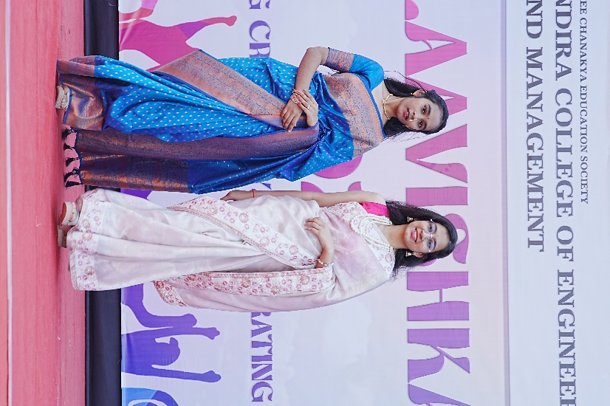
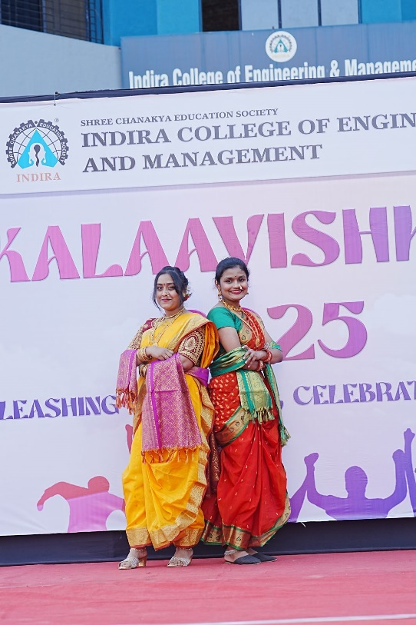

Preapred by: Submitted To:
Prof. Reshma Kohad Dr. Soumitra Das
Cultural Coordinator I/C Principal

